InnerJoin

1) Display the Cartesian product of the party and candidate table
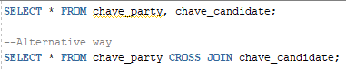

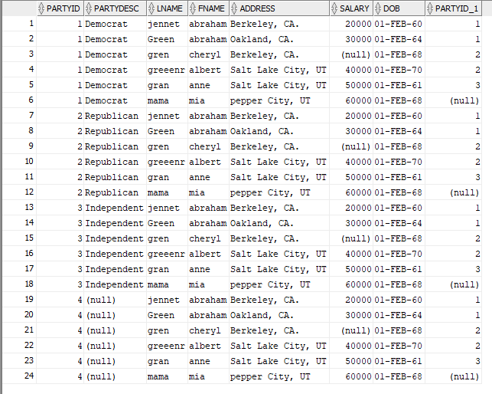
2) Display the lastname and the party description of each individual
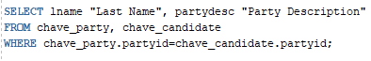

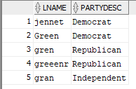
3) Display the last name and the party dscription of each individual. If there is not a party description, then display no description. (Use the NVL function)
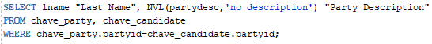

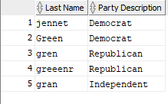
4) Display the number of people in each party (display party_description)
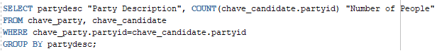

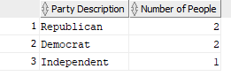
5) Display the number of people in each party for only those parties whose average salary is greater than 50,000. (Identify the party name)
